PHY 145 Lab 12: Atomic Spectra

Goals

 Gain an understanding of a Vernier scale.

Observe the spectral lines from different elements.

Measure the Rydberg constant using a spectrometer.

Activity 1: Vernier Scale Discussion

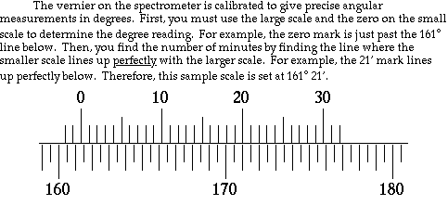

1. Since there are 60’ (sixty minutes) in a single degree, 21’ is the same as (21÷60) = 0.35°. So the above measurement is 161.35°.

2. Set your spectrometer at 180° 12’. Have your instructor check your setting. What is the equivalent decimal reading?

3. Notice on the large scale there is a line between every degree mark. This line represents 30’. If the 0 on the small scale is beyond the 30’ line, then 30’ must be added to the number on the small scale.

4. Set your spectrometer at 180° 48’. Have your instructor check your setting. What is the equivalent decimal reading?

5. You will use the Vernier scale to accurately measure angles. If your group is unclear about how to read the scale, discuss with your instructor before proceeding.

Activity 2: Helium Spectrum

This experiment should be performed in a darkened room.

1. Set up the spectrometer so that it is aimed at a Helium lamp. When looking through the eyepiece, you should see the slit located at the end of the tube closest to the Helium lamp. Move the eyepiece in or out to focus the crosshairs. Move the spectrometer so that the cross hairs are in the center of the slit.

2. Check that the diffraction grating is perpendicular to both tubes of the spectrometer.

3. Turn on the Helium lamp. Never touch the lamp while in operation; lethal voltages exist. While looking through the eyepiece, adjust the position of the lamp until it is the brightest through he slit.

4. Record the scale reading. This is your zero point. It should be very close to 180.00°. Zero point : ________.____°

5. Rotate the spectrometer until the bright yellow-orange line is centered on the cross hairs. Record this scale reading.

6. Rotate the spectrometer to the other side of zero until the bright yellow-orange line is visible again. Record this scale reading. The angle is measured on both sides of zero to offset any misalignment of the diffraction grating.

7. Using d sinθ = mλ, the expression for principle maxima from a diffraction grating, calculate d. The yellow-orange line has an accepted wavelength of λ = 587.562 × 10⁻⁹ m. The angle θ represents how far the spectrometer has been moved from the zero point (~180°). To calculate your θ, take the difference between the scale reading and the zero point, then use the average of the two measured values. Since this is a first order spectrum m = 1.

8. The grating was manufactured with a nominal slit spacing of d = 1.693 × 10⁻⁶ m. You have just completed this calibration to obtain a more accurate value for the slit spacing in the grating you are using.

Activity 3: Hydrogen Spectrum

This experiment should be performed in a darkened room.

1. Replace the Helium bulb with a Hydrogen bulb. Be sure that the power supply is unplugged when switching bulbs.

- Take angular measurements on each side of the zero point for the red, green, and blue lines.
Color | Measure  Angular position  Left | Zero  Point | Measure  Angular position  Right | Calc.  θ_{left} | Calc.  θ_{right} | Calc.  θ_{average} | Calibrated  d  (m) | Calc.  λ=d sinθ  (m)
Red
Green-blue
Blue-violet

3. Calculate the angle θ as the difference of angular position and zero point. Calculate the wavelengths for the lines using d sinθ = mλ, where the d value was previously calculated. Again use an average for the left and right angular results for θ. This is a first order spectrum, so m = 1.
4. Consider equation 30.2 from your text: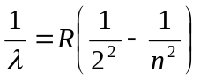. You have just calculated the wavelengths for the three colors which you measured. Each color also has a certain n value in the above expression: n = 3 (red), n = 4 (green), and n = 5 (blue). Solve the three following equations for R, the Rydberg constant. Then substitute the measured value of the respective wavelength to obtain a corresponding value of R.
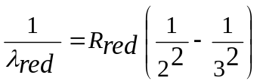where n = 3 has been used for red.
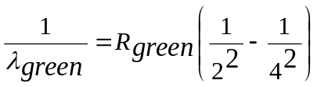where n = 4 has been used for green.
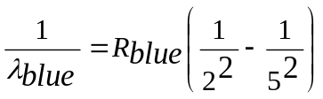where n = 5 has been used for blue.

5. Compute the average value of R.

6. Compare your values to the accepted values below.


